
AMERICAN INTERNATIONAL
UNIVERSITY BANGLADESH (AIUB)

FACULTY OF SCIENCE & TECHNOLOGY DEPARTMENT OF
ELECTRICAL AND ELECTRONICS ENGINEERING

Spring 2024-2025

DIGITAL LOGIC AND CIRCUITS LABORATORY

Section: D Group: 03

LAB REPORT NAME:
Design and Verilog HDL Modeling of Finite State Machines (FSM)
Supervised By:

S M TANVIR HASSAN SHOVON

Submitted By:

SL | Student ID | Student Name
1. | 23-50856-1 | Basudeb Kundu

Submition Date:24.06.2025

Title: Design and Verilog HDL Modeling of Finite State Machines (FSM)
Introduction:
This lab is intended for students to acquire the skills to design a Finite State Machine (FSM) at gate-level for a simple sequence generator. Later students will apply Verilog HDL to model and simulate their FSM.
Theory and Methodology:
FSM is a computational model that goes through a predetermined sequence of operations in a finite number of states. The purpose of FSM is to automate computational tasks. FSMs also serve as the general model of sequential logic circuits. In digital electronic circuits, they are widely used to implement control units of digital systems.
In control-dominated designs, such as signal generators (e.g., traffic light controllers) and stepper motor controllers, FSMs control operation of an external device such as LEDs or a stepper motor.


Reset
Clk

FSM
External device
Outputs

Control Inputs

In data-dominated designs, such as a microprocessor, FSMs control logical and arithmetic operations for the computations that the microprocessor needs to execute. In other words, it controls the operations of computing elements such as Arithmetic and Logic Units (ALU), storage devices for data such as registers and data steering circuits such as multiplexers and demultiplexers. FSM controls these operations through control signals (such as ALU_Control signals, select signals, load/enable signals for ALU, multiplexer and registers, respectively). To ensure proper control of these devices, sometimes the output states of these devices are read back by the FSM as status signals.

Note that the computations are done inside a datapath or data unit. The FSM serves as the control unit that guides the computations so that they are executed correctly and in the right sequence.


Reset
Outputs
Clk
FSM

Control Unit)
(
Datapath

(
Data Unit)
Control
Signals

Data Inputs

Control Inputs
Status Signals

Example 1: A Simple Signal Generator

Prepare the design for an FSM that stays in an idle state where it generates an output called Ready and evaluates the state of an input called Go. If Go is low, it stays in the idle state. If Go is high, it generates three outputs—Red, Green and Yellow—consecutively (one after another) for 2s, 2s and 1s, respectively. The RedGreen-Yellow sequence is repeated continuously (FSM does not return to the idle (initial) state)). The clock frequency is 1 Hz. Apply binary state encoding.

The following state diagram models the algorithm for this device.

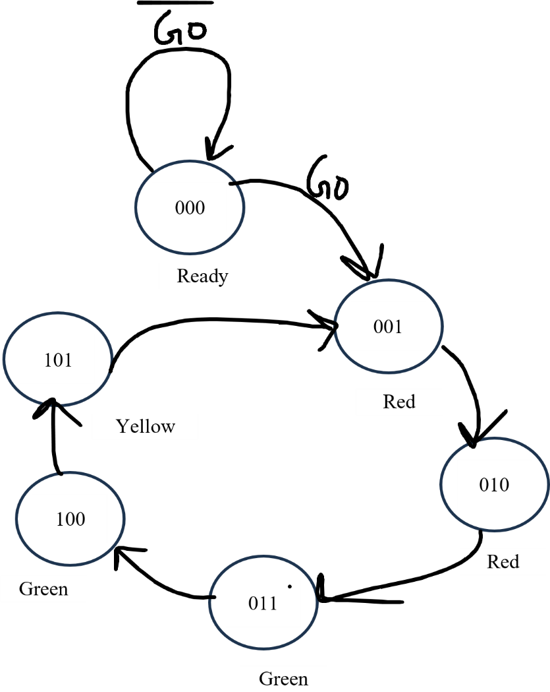

Apparatus:
- Computer with Internet Access
- Google account
3)Access to EDA Playground

Experimental Procedure:
• The logic equations for the next state signals and outputs are to be developed based on the defined state transitions and output behaviors of the FSM.
• The Verilog HDL code for the FSM is to be written using the provided design module template. The complete testbench module will be provided to facilitate simulation and verification.
• The design module is to be simulated to verify the correctness of state transitions and output behavior as per the FSM specification

Simulation And Results:

State Table:

Present State (P_STATE) | Input (GO) | Next State (N_STATE) | Output (Lights)
0 (IDLE) | 0 | 0 (IDLE) | None (All lights OFF)
0 (IDLE) | 1 | 1 (RED) | Red ON
1 (RED) | 0 | 2 (GREEN) | Green ON
1 (RED) | 1 | 1 (RED) | Red remains ON
2 (GREEN) | 0 | 3 (YELLOW) | Yellow ON
2 (GREEN) | 1 | 2 (GREEN) | Green remains ON
3 (YELLOW) | 0 | 0 (IDLE) | Red ON (transition to next cycle)
3 (YELLOW) | 1 | 3 (YELLOW) | Yellow remains ON

Logic Equations:
Each output (Red, Green, Yellow) can be derived from a logic equation based on the current state (P_STATE).

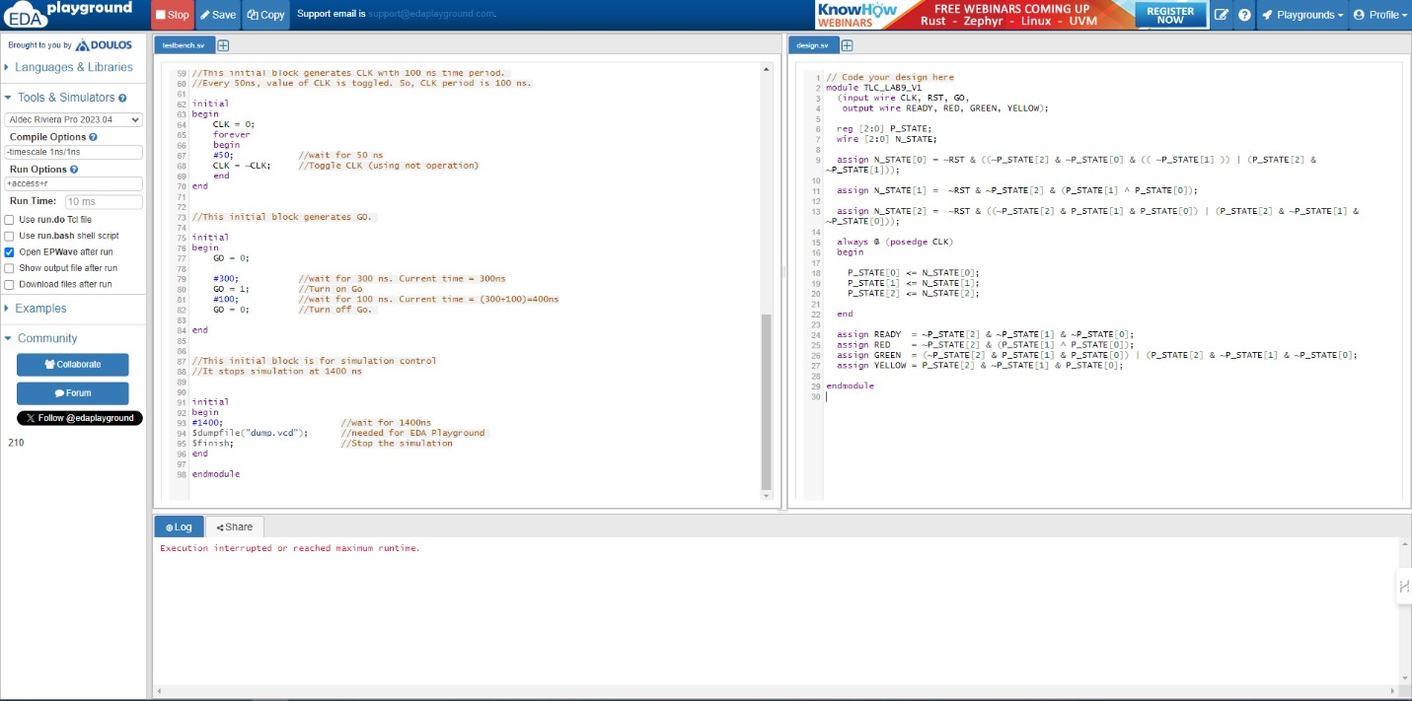

Red:
Red = P_STATE[1] Green:
Green = P_STATE[2]
Yellow:
Yellow = P_STATE[0] & ~P_STATE[1] & ~P_STATE[2] // True only in the YELLOW state (P_STATE = 010)
2. Next State Logic (Combinational Approach):
We can derive logic equations for each next state (N_STATE) based on the current state (P_STATE) and the input (GO). This is a combinational approach suitable for hardware implementation.
N_STATE[0] (Least Significant Bit):
N_STATE[0] = P_STATE[2] & ~P_STATE[1] & ~GO // Transition to YELLOW from GREEN on falling edge of GO
N_STATE[1] (Middle Bit):
N_STATE[1] = (P_STATE[0] & ~P_STATE[1] & ~P_STATE[2] & GO) | // Transition to RED from YELLOW on rising edge of GO
(P_STATE[1] & ~GO) // Stay in RED if GO goes low

Functional Simulation:

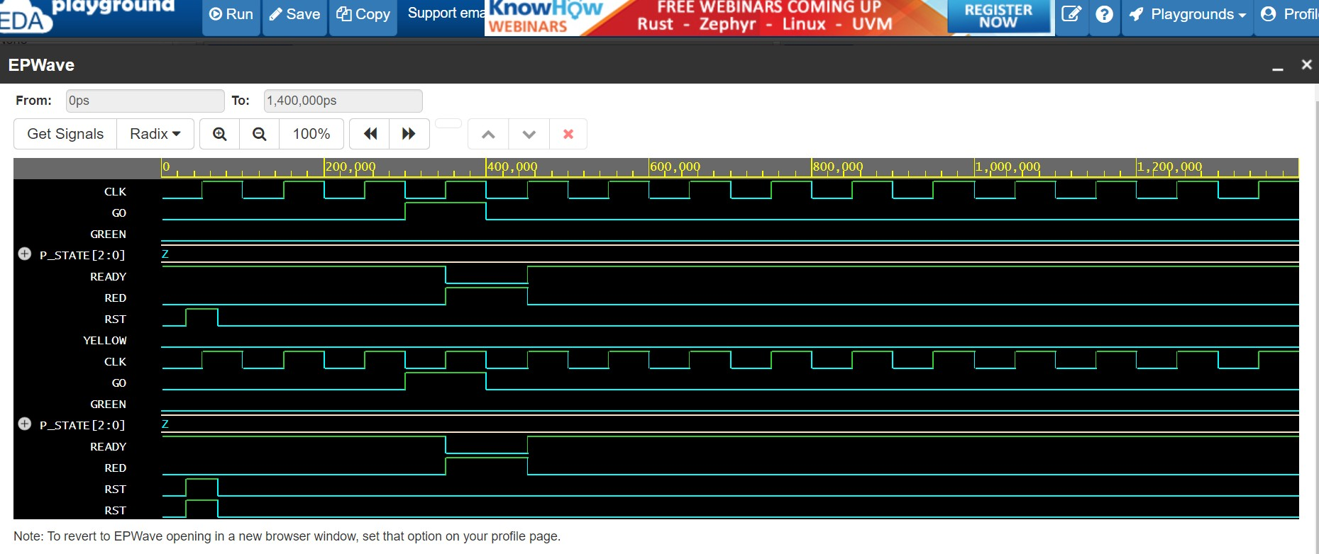

Result and Discussion:
Interpret the data/findings and determine the extent to which the experiment was successful in complying with the goal that was initially set. Discuss any mistake you might have made while conducting the investigation and describe ways the study could have been improved.

  - Combinational Approach: This method expresses each next state as a function of the current state and input, but it may lead to redundant logic in hardware implementation.
  - Sequential Approach (Flip-Flops): This is a common practice in FSM design, but representing it with logic equations wouldn't be very practical compared to state registers and next-state logic.

Conclusion:
This exploration into the design of a traffic light controller using a Finite State Machine (FSM) has produced meaningful outcomes. The key achievements include:
- State Table: A detailed state table was developed to clearly represent the traffic light sequence (Red → Green → Yellow → repeat) based on the GO signal and corresponding light outputs. This table provides a straightforward reference for understanding FSM behavior.
- Verilog Code: Structured and functional Verilog code was written to simulate the FSM accurately. The code incorporates state registers and next-state logic to ensure proper implementation of state transitions, making it suitable for both simulation and hardware deployment.
- Logic Equations: Various logic equation approaches were examined to express the FSM behavior. While useful for analyzing individual outputs or specific transitions, logic equations are generally less practical for representing the complete FSM in hardware design.

Reference:
- Thomas L. Floyd, Digital Fundamentals, 9th Edition, 2006, Prentice Hall.
- Michael Ciletti, Advanced Digital Design with the Verilog HDL-2nd Edition, 2010.
- Doughlas J. Smith, HDL Chip Design-A Practical Guide for Designing, Synthesizing and Simulating ASICs & FPGAs using VHDL or Verilog, 1997.

